1. Swartvlei Estuary Fishing Effort

Generalized least squares fit by REML

Model: Single_Count ~ Lockdown_level

Data: swart

AIC BIC logLik

324.3402 337.863 -155.1701

Correlation Structure: ARMA(0,2)

Formula: ~1 | Year

Parameter estimate(s):

Theta1 Theta2

0.3398910 0.2555024

Coefficients:

Value Std.Error t-value p-value

(Intercept) 4.726893 1.065738 4.435322 0.0000

Lockdown_levelLevel 3 25.810034 4.229481 6.102412 0.0000

Lockdown_levelLevel 4 11.025543 3.475419 3.172436 0.0026

Lockdown_levelLevel 5 -1.369940 3.870046 -0.353985 0.7248

Correlation:

(Intr) Lck_L3 Lck_L4

Lockdown_levelLevel 3 -0.252

Lockdown_levelLevel 4 -0.307 0.278

Lockdown_levelLevel 5 -0.275 0.109 0.243

Standardized residuals:

Min Q1 Med Q3 Max

-2.0674557 -0.5848946 -0.1397655 0.4370681 3.5135142

Residual standard error: 5.200806

Degrees of freedom: 55 total; 51 residual

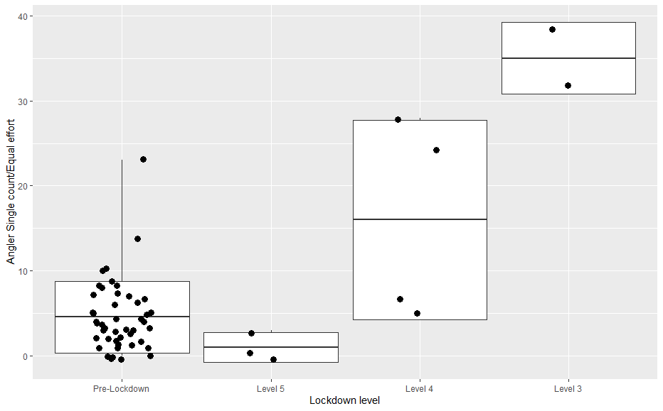

1. Knysna Estuary Fishing Effort

**Relevel _between April and June across years**

**Knysna estuary angler counts**

Generalized least squares fit by REML

Model: Anglers ~ Lockdown_level

Data: KnyFish

AIC BIC logLik

518.0237 529.6147 -253.0119

Correlation Structure: ARMA(0,2)

Formula: ~1 | Year

Parameter estimate(s):

Theta1 Theta2

-0.02926423 0.19589196

Coefficients:

Value Std.Error t-value p-value

(Intercept) 46.13233 5.308624 8.690073 0.0000

Lockdown_levelLevel 3 117.49026 20.437306 5.748813 0.0000

Lockdown_levelLevel 5 -49.67337 20.437306 -2.430524 0.0186

Correlation:

(Intr) Lck_L3

Lockdown_levelLevel 3 -0.260

Lockdown_levelLevel 5 -0.260 0.176

Standardized residuals:

Min Q1 Med Q3 Max

-2.00900625 -0.63724606 -0.01906787 0.27494371 3.28290831

Residual standard error: 33.16196

Degrees of freedom: 54 total; 51 residual

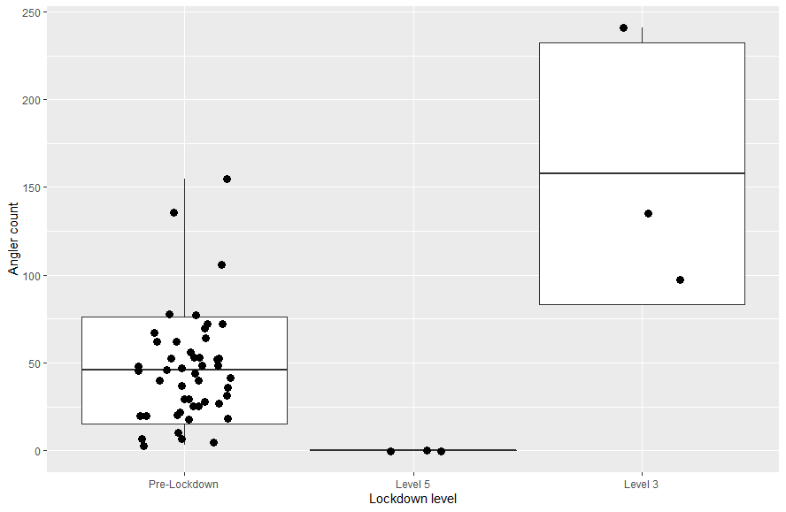

1. **Knynsa Estuary watercraft activity**

glm(formula = Count ~ Lockdown_level, family = stats::gaussian,

data = boat)

Deviance Residuals:

Min 1Q Median 3Q Max

-14.333 -6.083 0.000 0.500 17.667

Coefficients:

Estimate Std. Error t value Pr(>|t|)

(Intercept) 14.333 3.269 4.384 0.000623 ***

Lockdown_levelLevel 3 16.000 6.538 2.447 0.028203 *

Lockdown_levelLevel 4 -14.333 6.538 -2.192 0.045768 *

Lockdown_levelLevel 5 -14.333 6.538 -2.192 0.045768 *

---

Signif. codes: 0 ‘***’ 0.001 ‘**’ 0.01 ‘*’ 0.05 ‘.’ 0.1 ‘ ’ 1

(Dispersion parameter for gaussian family taken to be 96.19048)

Null deviance: 3267.1 on 17 degrees of freedom

Residual deviance: 1346.7 on 14 degrees of freedom

AIC: 138.75

